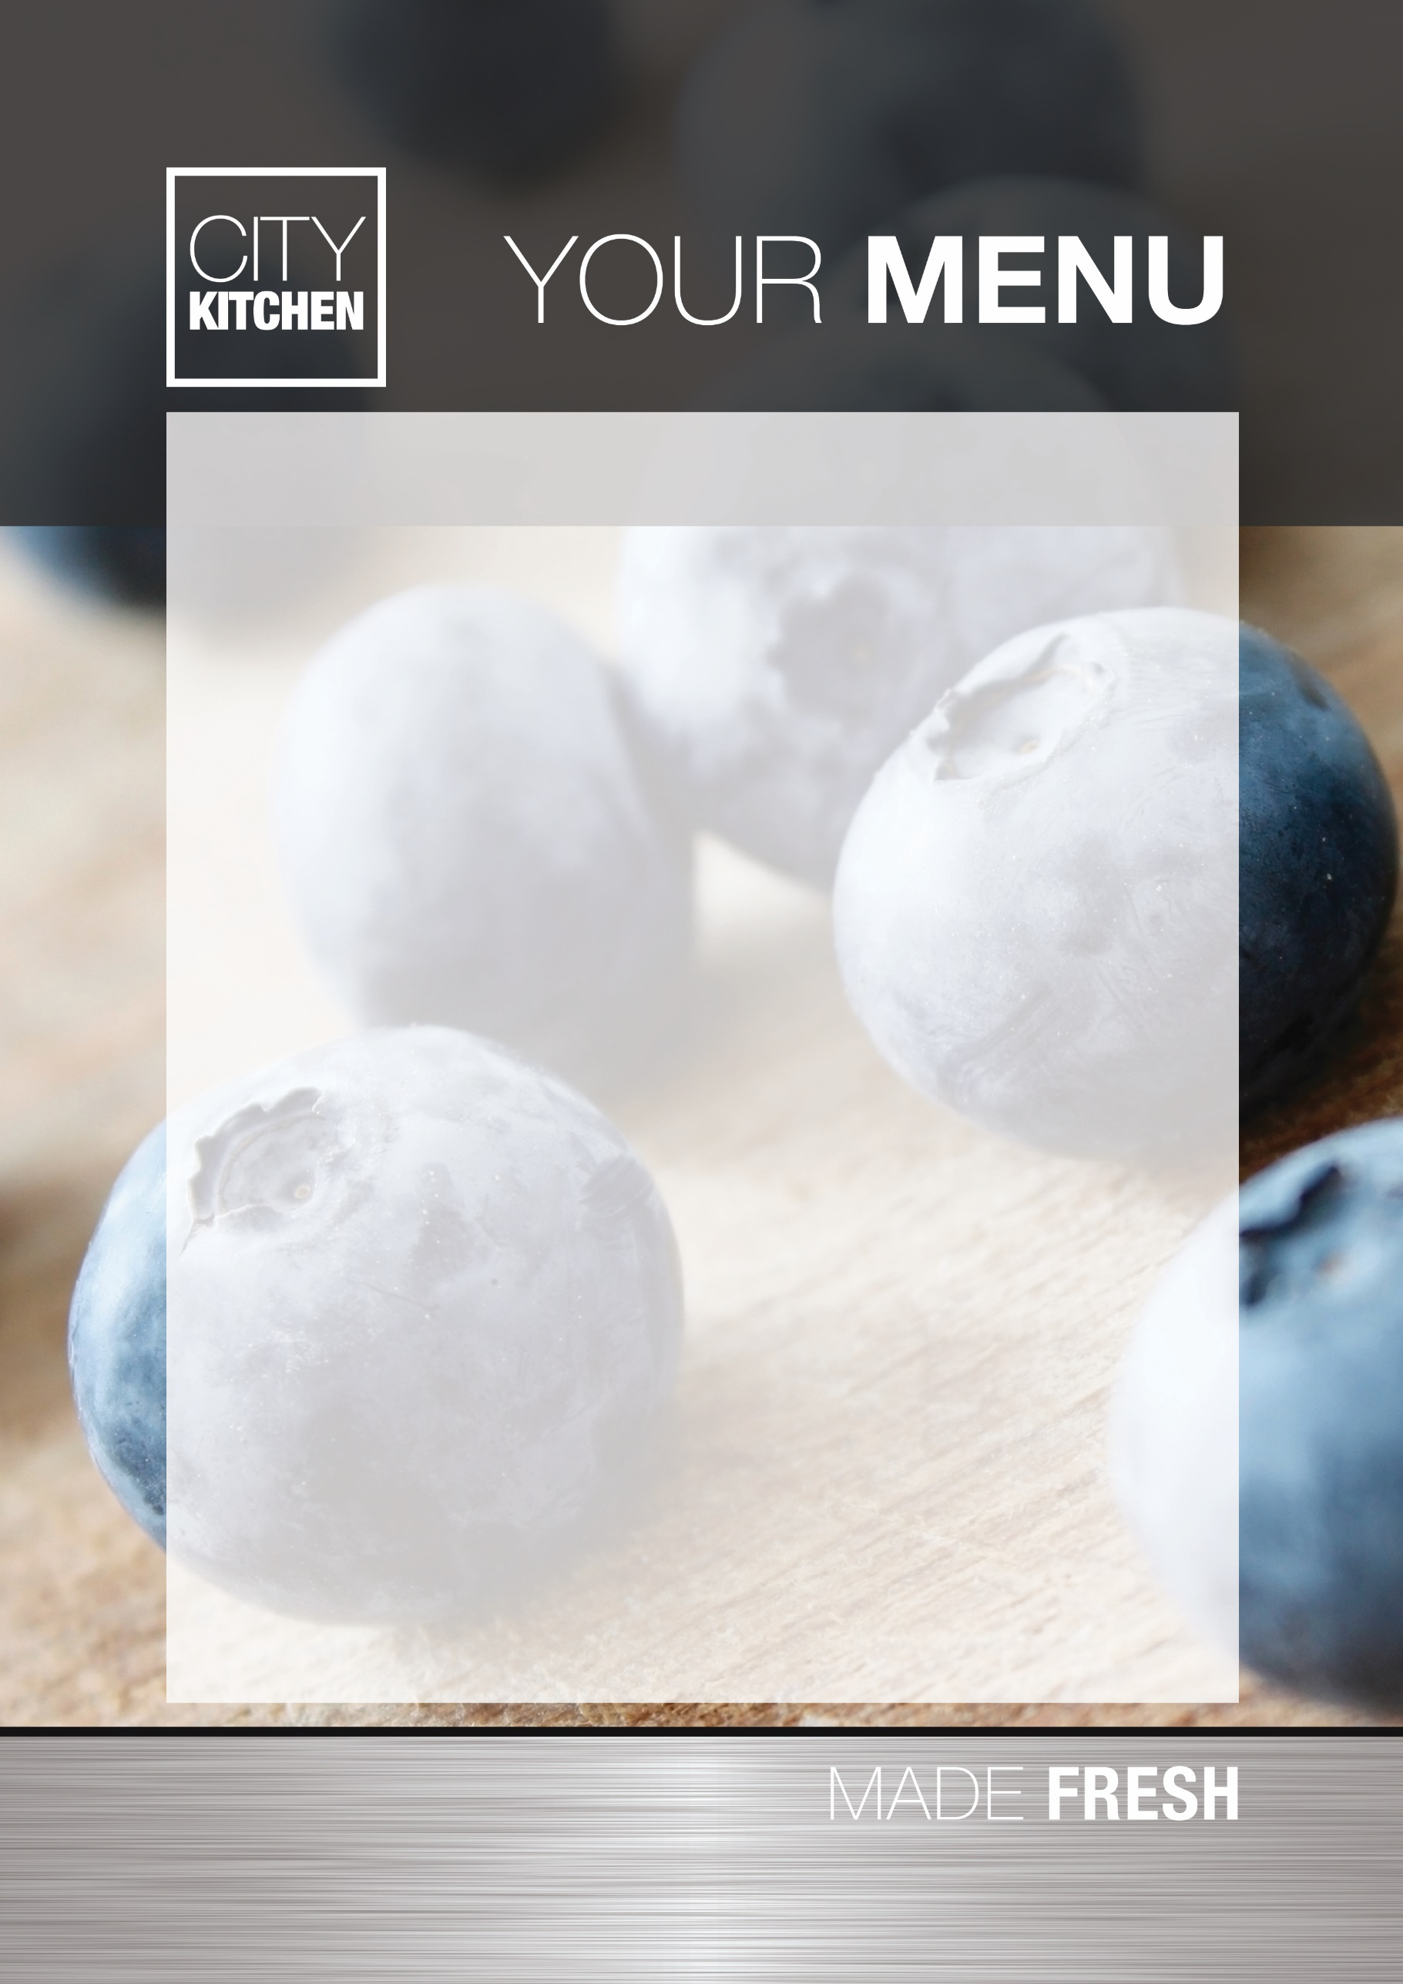
Breakfast & Mid-Morning Break 2026/27

Toast (per slice) 35p
Cereal with milk 90p
Yoghurt 95p
Fresh Fruit 65p
Beans on Toast £1.10
Cheese on Toast £1.10
Bacon Sandwich (full) £1.90
Bacon Sandwich (half) 95p
Radnor Fruit Tetra (125ml) 60p
Radnor Tetra (200ml) 90p
Still Water (330ml) 85p
Viva Flavoured Milk (200ml) £1.10

