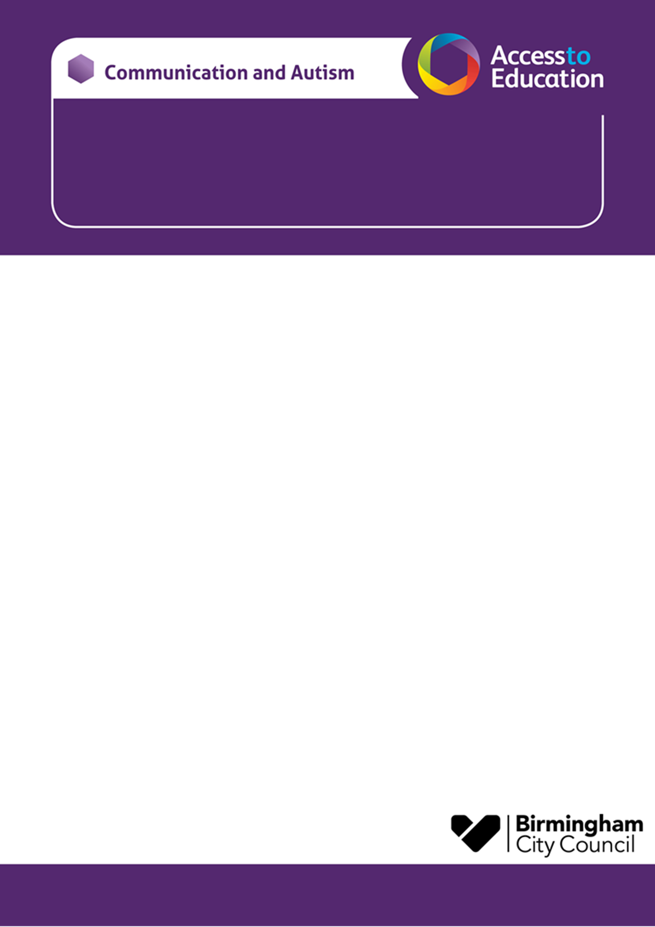

Communication and Autism Team
Autumn Parent Session - SOUTH BIRMINGHAM

Come along and meet Katie and Lisa from the Communication and Autism Team (CAT).
This is an opportunity for you to:
- Meet other parent/carers with autistic children and young people
- Find out a bit more about autism
- Ask questions
- Have some time to reflect and recharge
The sessions will be delivered face to face termly at the following venue and time:
Northfield Manor Primary Academy  Swarthmore Rd,  Selly Oak,  Birmingham  B29 4JT | Wednesday 25th October 2023  9.30 – 11.30am
Please note: we do not have any childcare facilities at the venue.
If you have any questions, please contact us.
Just turn up on the day – there is no need to book. We look forward to seeing you there!
Katie Price & Lisa Walmsley
CATParentEnquiries@birmingham.gov.uk

