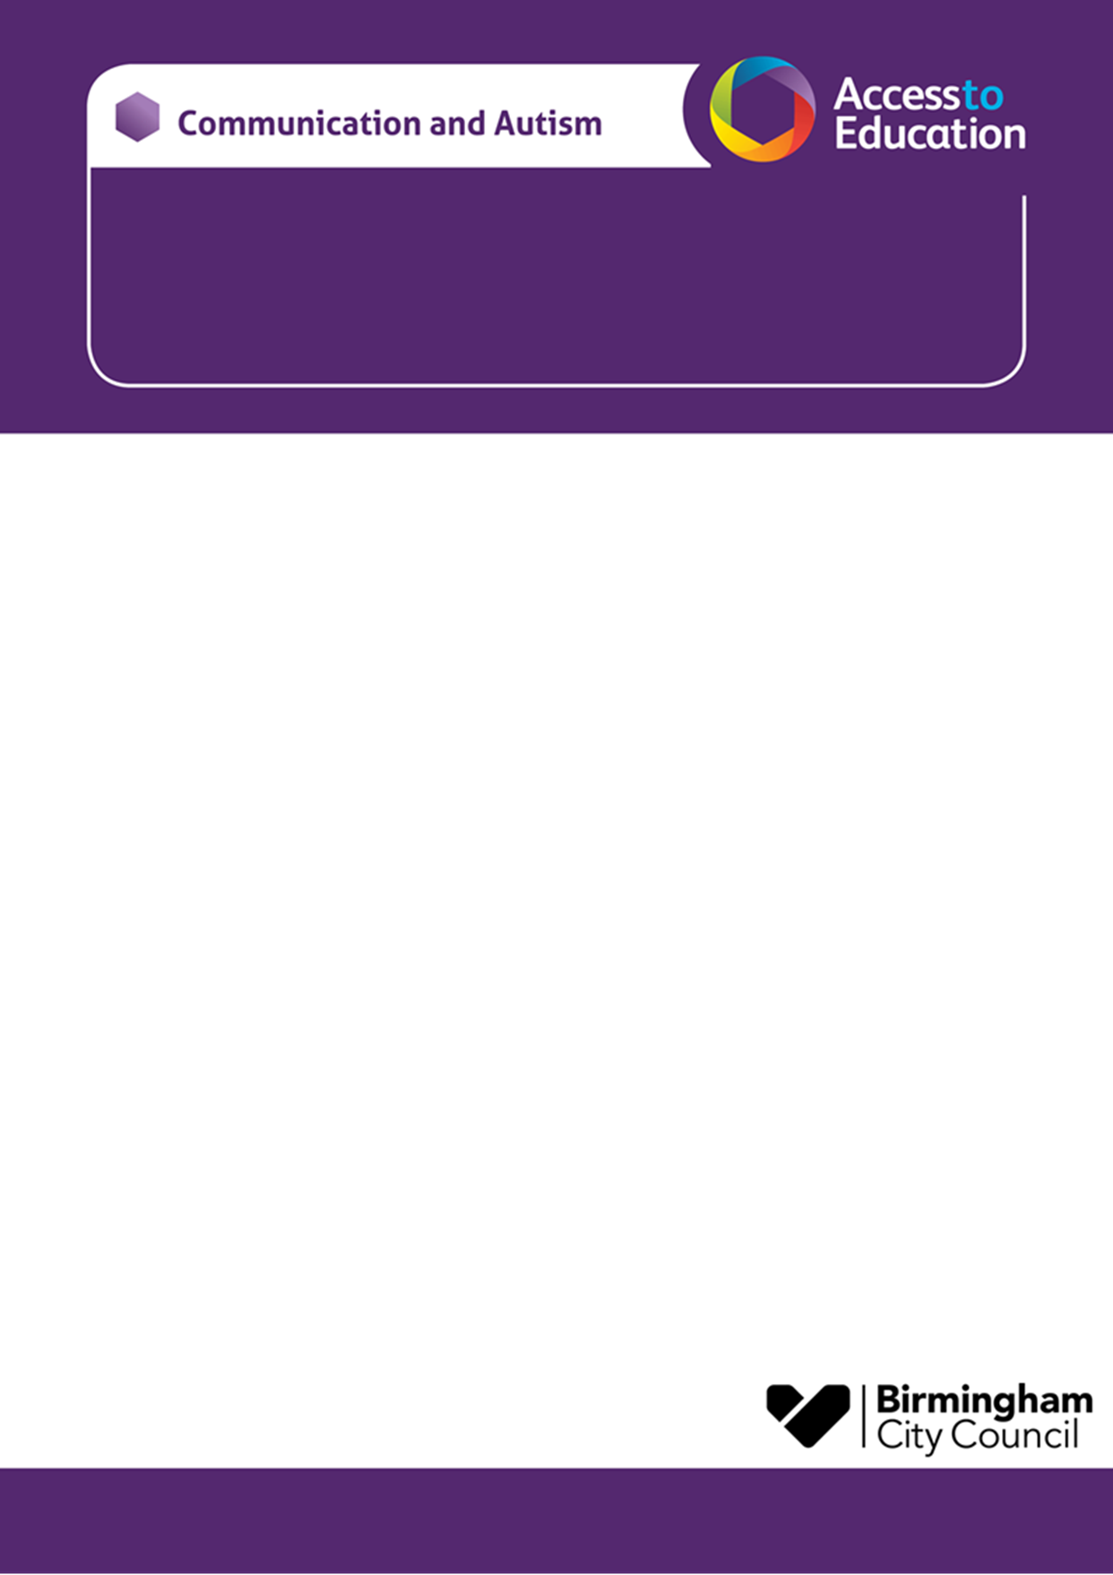

Communication and Autism Team - Parent Workshop / Drop in Session
SOUTH – Colmore Junior School , Birmingham, B14 6AJ

Come along and meet Wendy and Lisa from the Communication and Autism Team (CAT).
This is an opportunity for you to meet other parent carers with autistic children, or children who are on the neurodevelopmental pathway for assessment.

- For parent carers of children / young people of all ages
- Find out a bit more about autism
- Ask questions
- Have some time to reflect and share ideas and experiences

The session will be held at:  Colmore Junior School  B14 6AJ | Date and Time:  Thursday 23rd January  9.30 - 11.30am
(Please note there are no childcare facilities at the venue.)
If you have any questions, please contact the email below:
joanne.clifford@birmingham.gov.uk
Just turn up on the day – there is no need to book. We look forward to seeing you there!
Wendy Bantock and Lisa Walmsley

