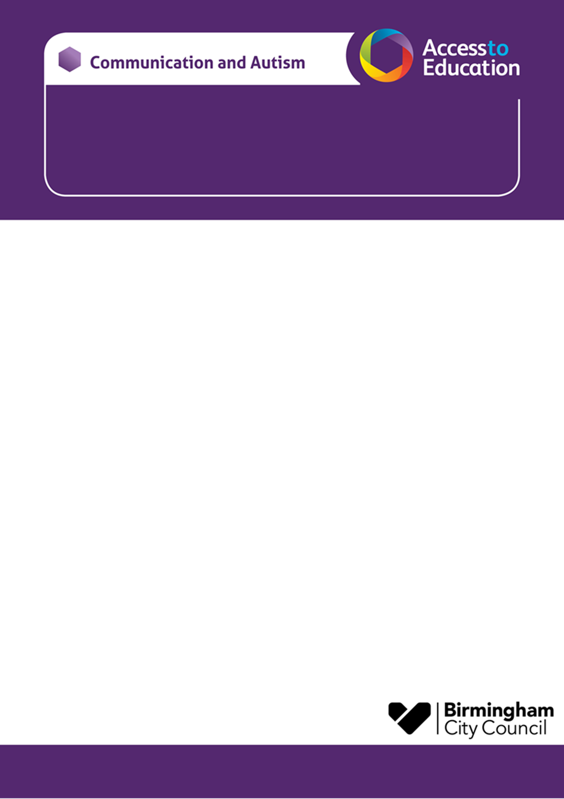

Monday 9th June 2.00-3.30pm
A Workshop for Parent Carers of Year 6 Children on CAT Caseload
moving from Primary to Secondary School

This CAT transition to secondary school workshop will help you:

- Consider how to support your child’s independence skills as they move from primary to secondary.
- Consider how to prepare your child for this time of change in their lives.
- Think about how you can work alongside your child and their school to support a smooth transition.
- Consider ways to support your child to build confidence, resilience and independence for the changes ahead.
(you only need to book on / attend one of the workshops the afternoon or evening session)

- The workshop will be delivered virtually via Microsoft TEAMs.
- Each session will last for 90 minutes.

CAT transition to secondary school Daytime Workshop  Monday 9th June 2025 | 2.00pm - 3.30pm
To secure a place for the workshop please visit the:
Parent Carer Transition Primary to Secondary Monday 9th June 2025 2:00pm to 3:30pm - Local Offer Birmingham
https://www.localofferbirmingham.co.uk/product/parent-carer-transition-primary-to-secondary-monday-9th-june-2025/

Kind Regards, Jo Clifford and Wendy Bantock.

